**B.TECH**

**PROJECT REPORT**

**ON**

**“foodsquare.com”**

**Submitted For Partial Fulfillment of the Requirements**

**For the award of Degree of**

**Uttrakhand Technical University (UTU), Dehradun**



**Guided By: Submitted By:**

**Ms Neha Arora Harshul Khurana**

**(Astt. Professor) 651490600014**

**Department of Computer Science & Engineering**

**Department of Computer Science & Engineering**

**College of Engineering Roorkee**

**7th Km Roorkee Haridwar Road, Vardhman Puram**

**Roorkee, Haridwar (U.K)**

**Session 2016-2017**



**CERTIFICATE**

This is to certify that “**Harshul Khurana**” student of **Master Of Computer Application** (VI semester), College of Engineering Roorkee, Roorkee have satisfactorily completed the project on the topic “ **Airline Reservation System** ” as per the rules of **Uttrakhand Technical University, Dehradun** in the academic session 2015-2017.

His/Her performance was satisfactory during the development of project.

**Ms Kanika Sharma Dr. Vishal Singhal (External Examiner)**

**(Astt. Professor) (HOD)**

**Department of MCA Department of MCA**

**COER COER**

**Candidate’s Declaration**

I hereby certify that the work which is presented in this project report entitled “**Airline Reservation System**“ is an authentic record of my work carried out under the supervision of “**Ms. Kanika Sharma**” Department of Master of Computer Application, College of Engineering Roorkee, Roorkee.

The matter embodied in this dissertation has not been submitted by me for the award of any other degree.

DATE : **Rishabh Narayan Parasar**

This is to certify that above statement made by the candidate is correct to the best of my knowledge.

Name Of Guide

**Ms. Kanika Sharma**

**(Astt. Professor)**

**Department of MCA**

**COER**

**ACKNOWLEDGEMENT**

I have taken efforts in this project. However, it would not have been possible without the kind support and help of many individuals and organizations. I would like to extend my sincere thanks to all of them.

I am highly indebted to Mr. Rishabh Sharma for their guidance and constant supervision as well as for providing necessary information regarding the project & also for their support in completing the project.

I would like to express my gratitude towards my parents & member of Cyber Worx Technologies Pvt. Ltd.for their kind co-operation and encouragement which help me in completion of this project.

I would like to express my special gratitude and thanks to industry persons for giving me such attention and time.

My thanks and appreciations also go to my colleague in developing the project and people who have willingly helped me out with their abilities.

Thanking you!

Harshul Khurana

…………….

**Contents**

1. Vision Statement 2

1.1 Project Goals . . . . . . . . . . . . . . . . . . . . . . . . . . . . . . . . . . . . . . . . . 2

1.2 Users of the Project . . . . . . . . . . . . . . . . . . . . . . . . . . . . . . . . . . . . . 2

1.3 Project Features . . . . . . . . . . . . . . . . . . . . . . . . . . . . . . . . . . . . . . . 2

1.4 Milestones . . . . . . . . . . . . . . . . . . . . . . . . . . . . . . . . . . . . . . . . . . . 3

1. Architecture and Design 3

2.1 Tools and Frameworks . . . . . . . . . . . . . . . . . . . . . . . . . . . . . . . . . . . . 3

2.2 Entity Relationship Diagram . . . . . . . . . . . . . . . . . . . . . . . . . . . . . . . . 4

1. User Guide 7

3.1 Customer User Guide . . . . . . . . . . . . . . . . . . . . . . . . . . . . . . . . . . . . 7

3.1.1 Restaurant Homepage . . . . . . . . . . . . . . . . . . . . . . . . . . . . . . . . 7

3.1.2 Customer Location Prompt . . . . . . . . . . . . . . . . . . . . . . . . . . . . . 8

3.1.3 Customer Registration . . . . . . . . . . . . . . . . . . . . . . . . . . . . . . . . 8

3.1.4 View Restaurants . . . . . . . . . . . . . . . . . . . . . . . . . . . . . . . . . . . 9

3.1.5 Browse Cuisines 10

3.1.6 Branch Unavailability 11

3.1.7 Adding food to cart and Checkout 12

3.1.8 Payment method 13

3.1.9 Order Placing notification 14

3.1.10 Rate the Deliveryman 14

3.1.11 Rate and Comment Items 15

* 1. Restaurant Manager User Guide 16
     1. Manager Register 16
     2. Restaurant Manager Homepage 17
     3. Restaurant Branch Creation 18
     4. Add Items 19
     5. Manager Dashboard 20
  2. Restaurant Branch Manager 21
     1. Item Availability in the branch 21
     2. Add offer 22
     3. Manage and Accept Orders 23
  3. Deliveryman User Guide 24
     1. Deliveryman Register 24
     2. Deliveryman Homepage 25
     3. Complete the Delivery Process 26

# Vision Statement

## Project Goals

*Foodsquare* is an online restaurant management system. It works as a restaurant hub where people can browse and order food online easily. Now a days, many people in Dhaka city, especially the young generation, often want to order food from restaurants online with home delivery service. Thus, we built a restaurant management system where all the restaurants information, services will be available. We also offer deliverymen will deliver the foods as well, in case a restaurant does not have delivery support.

## Users of the Project

*Foodsquare* has four (4) kind of users. They are:

* + - Customers
    - Restaurant Managers
    - Restaurant Branch Managers
    - Deliveryman

Apart from the users, there is a *superuser* named *admin*. Anyone can connect to the system as customer, restaurant manager, deliveryman. *admin* will verify the Trade Licence No. and many other details of a restaurant before connecting it to the system. Similarly, a deliveryman will also get checked by the *admin* about whether s/he is capable enough to work as a deliveryman.

## Project Features

There are many features that are implemented in the project. Among these, key features of our project are as follows.

* + - Dashboard for the restaurant managers
    - Search and filter food items
    - Our own delivery module
    - Bi-directional rating system between deliveryman and customer
    - Offers and Discounts
    - Rating and review submission system

## Milestones

According to *CSE 408 Software Engineering* course’s outline, we created the milestones of our project which is shown below.

|  |  |
| --- | --- |
| **Week** | **Task** |
| Week 03 | Project Update: Database Design and Implementation |
| Week 04 | Project Update: User Account module |
| Week 05 | First Prototype demonstration; Manager Profile implementation and Restaurant  management module |
| Week 06 | Project Update: Order management module |
| Week 07 | Project Update: Branch management implementation |
| Week 08 | Second Prototype demonstration; Review, Delivery module implementation |
| Week 09 | Project Update: Adding Notifications and other issues resolved |
| Week 10 | Project Update: Offer and Discounts |
| Week 11 | Unit Testing: Testing with different types of data and error resolve |
| Week 12 | Project Update: Dashboard implementation from manager side |
| Week 13 | Project Update: |

# Architecture and Design

## Tools and Frameworks

For our coding, we used the following tools and fram in osur project.

* + - Frontend
      * HTML

∗ CSS

∗ Bootstrap

* + - * Javascript

∗ Angular JS

∗ JQuery

∗ Google Maps API

* + - Backend
      * Django
    - Database
      * Postgresql v10.2

## Entity Relationship Diagram

The Entity Relationship Diagram of the project is provided in the next page.

0..*



1

0..*

CharField CharField ContentTypeManager

QuerySet

app_label model objects

permission_set

django.contrib.contenttypes.models.ContentTy

|  |  |
| --- | --- |
| django.contrib.auth.models.Permissi | |
| codename | CharField |
| content_type | ForeignKey |
| group_set | QuerySet |
| name | CharField |
| objects | PermissionManager |

0.



0..*

0..*

0..*

accounts.models.User

is_branch_manager BooleanField is_customer BooleanField is_delivery_man BooleanField is_manager BooleanField is_suspended BooleanField

order_set QuerySet

1

1

1 0..*

1

1

1

accounts.models.DeliveryMa

1

1

address avatar contactNum delivery_set name

nid

user

CharField ImageField CharField QuerySet CharField CharField

OneToOneField

e.BranchComment';

1

1

0..*

0..*

1

accounts.models.RestaurantBranc

0..*

accounts.models.Deliver

address CharField

address_desc CharField

charge FloatField

deliveryman ForeignKey

location CharField

order_set QuerySet rating_deliveryman IntegerField rating_user IntegerField

time DateTimeField

branch_email branch_location branch_location_details branch_mobilenum branch_name branch_phonenum closing_time comments

image location_area opening_time order_set ratings restaurant running

user

1

CharField CharField CharField CharField CharField CharField FloatField ManyToManyField

ImageField CharField FloatField QuerySet ManyToManyField

ForeignKey BooleanField

OneToOneField

browse.models.Package

available

BooleanField

branch_details ManyToManyField

accounts.models.Paymen

bkash_ref order_set payment_status payment_type

price

CharField QuerySet CharField CharField

FloatField

1

1

category comments details for_n_persons image ingr_list is_vegeterian order_set pkg_name price

ratings

restaurant

CharField ManyToManyField

CharField IntegerField ImageField ManyToManyField

BooleanField QuerySet CharField IntegerField ManyToManyField

ForeignKey

0..*

1

0..* 0..* 0..*

0..* 0..*

through = 'OrderPackageList';

0..*

restaurantImg ImageField

restaurant_key CharField restaurant_name throughCh=a'rbFrioelwds restaurantbranch_set QuerySet

trade_license CharField

user OneToOneField

accounts.models.Restauran



.* 0..*



0..*

|  |  |
| --- | --- |
| django.contrib.auth.models.Grou | |
| name | CharField |
| objects | GroupManager |
| permissions | ManyToManyField |
| user_set | QuerySet |

|  |  |
| --- | --- |
| accounts.models.UserProfil | |
| address | TextField |
| avatar | ImageField |
| first_name | CharField |
| last_name | CharField |
| user | OneToOneField |

|  |  |  |
| --- | --- | --- |
| accounts.models.Orde | |  |
| branch ForeignKey  delivery ForeignKey  mobileNo CharField  order_status CharField orderpackagelist_set QuerySet payment ForeignKey pkg_list ManyToManyField time DateTimeField  user ForeignKey | |
| 1 |  | |

|  |  |
| --- | --- |
| accounts.models.OrderPackageLis | |
| order | ForeignKey |
| package | ForeignKey |
| price | FloatField |
| quantity | IntegerField |



1

0..*

CharField CharField ContentTypeManager

QuerySet

app_label model objects

permission_set

django.contrib.contenttypes.models.ContentTy

|  |  |
| --- | --- |
| django.contrib.auth.models.Permissi | |
| codename | CharField |
| content_type | ForeignKey |
| group_set | QuerySet |
| name | CharField |
| objects | PermissionManager |

0..*

0..*

0..*



0..*

0..*

0..*

accounts.models.User

is_branch_manager BooleanField is_customer BooleanField

is_delivery_man BooleanField

is_manager BooleanField

is_suspended BooleanField packagecommentreact_set QuerySet

0..* 10..* 10..* 1 1 1 0..* 1 1 1

1

through = 'browse.BranchComment';

1

1

0..*

0..*

1

accounts.models.RestaurantBranc

through = 'PackageComment';

ingredientlist_set

name

QuerySet

CharField

1

0..*

through = 'PackageCommentReact';

through = 'IngredientList';

branch_email branch_location branch_location_details branch_mobilenum branch_name branch_phonenum branchcomment_set closing_time comments

image location_area opening_time ratings restaurant running

user

CharField CharField CharField CharField CharField CharField QuerySet FloatField ManyToManyField

ImageField CharField FloatField ManyToManyField

ForeignKey BooleanField OneToOneField

1

through = 'BranchCommentReact';

browse.models.Ingredien

0..*

0..* 0..* 0..*

through = 'PackageB 0..*

ranchDetails'; 1

1

browse.models.Package

available

BooleanField

branch_details ManyToManyField

0..*

0..*

0..*

category CharField

comments ManyToManyField

0..*

0..*

browse.models.BranchCommen

details CharField branch ForeignKey

for_n_persons IntegerField branchcommentreact_set QuerySet

image ImageField comment CharField

ingr_list ManyToManyField

is_vegeterian BooleanField

packagerating_set pkg_name

price

QuerySet CharField

IntegerField

reacts time

user

ManyToManyField DateTimeField

ForeignKey

1

ratings ManyToManyField

restaurant ForeignKey

1 1 1 1

0..* 0..*

0..*

0..*

0..*

browse.models.PackageBranchDetail

browse.models.PackageCommen

0..*

comment CharField

package ForeignKey

packagecommentreact_set QuerySet reacts ManyToManyField

time DateTimeField

user ForeignKey

1

available branch offer_buy_n offer_discount

offer_expire_date offer_get_n offer_start_date offer_type

package

BooleanField ForeignKey IntegerField IntegerField DateField IntegerField DateField CharField

ForeignKey

0..*

0..*

0..*

0..*

0..*

0..*

0..*

ForeignKey

ForeignKey

ingredient

package

browse.models.IngredientLis

ForeignKey IntegerField

ForeignKey

package rating

user

browse.models.PackageRatin

ForeignKey IntegerField

ForeignKey

branch rating

user

browse.models.BranchRatin



|  |  |
| --- | --- |
| django.contrib.auth.models.Grou | |
| name | CharField |
| objects | GroupManager |
| permissions | ManyToManyField |
| user_set | QuerySet |

|  |  |
| --- | --- |
| accounts.models.Restauran | |
| restaurantImg | ImageField |
| restaurant_key | CharField |
| restaurant_name | CharField |
| restaurantbranch_set | QuerySet |
| trade_license | CharField |
| user | OneToOneField |

|  |  |
| --- | --- |
| browse.models.BranchCommentReac | |
| disliked | BooleanField |
| liked | BooleanField |
| post | ForeignKey |
| user | ForeignKey |

|  |  |
| --- | --- |
| browse.models.PackageCommentReac | |
| disliked | BooleanField |
| liked | BooleanField |
| post | ForeignKey |
| user | ForeignKey |

# User Guide

This is a sample user guide that will work as a walk-through of the major functionalities of the *FoodSquare* website. As mentioned above, there are 4 kinds of users in this system. A user guide is provided for each kind of user below.

## Customer User Guide

### Restaurant Homepage

Most of the users of the website will be of this category. Initially, a customer will be able to browse through the website even without login. Thus, every time a customer enters the website, the customer home page will be loaded.

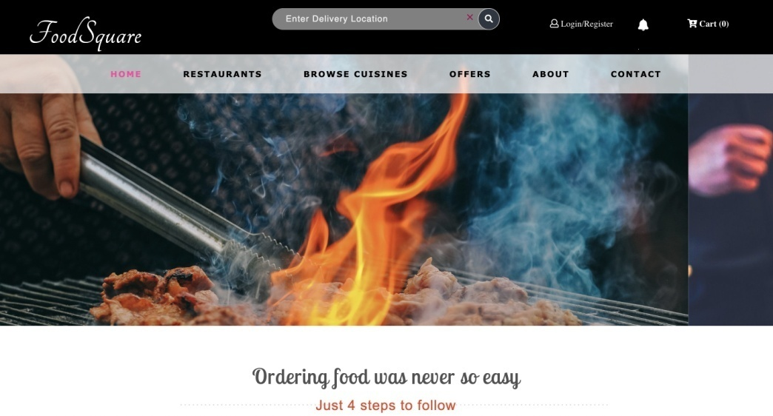

Figure 1: Website Homepage

### Customer Location Prompt

But when the customer will try to order something from the website, location prompt will appear.

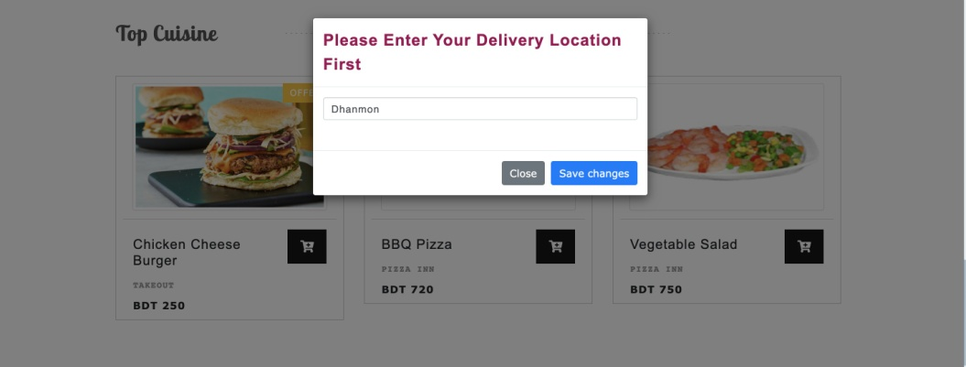

Figure 2: Customer Location prompt

### Customer Registration

After entering location, the customer will be able to browse the website as before but cannot order until login/register is done.

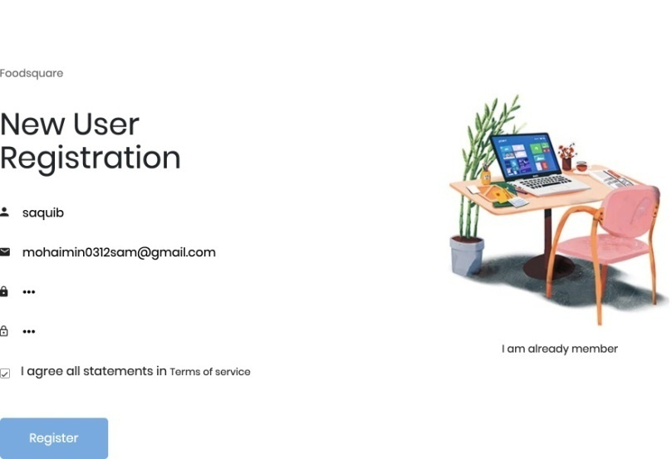

Figure 3: Customer Registration

### View Restaurants

While browsing the items, a customer can filter the items via many different search categories. Among these, in the *Restaurants* page, a user will be able to see only the restaurants that are close to him/her.

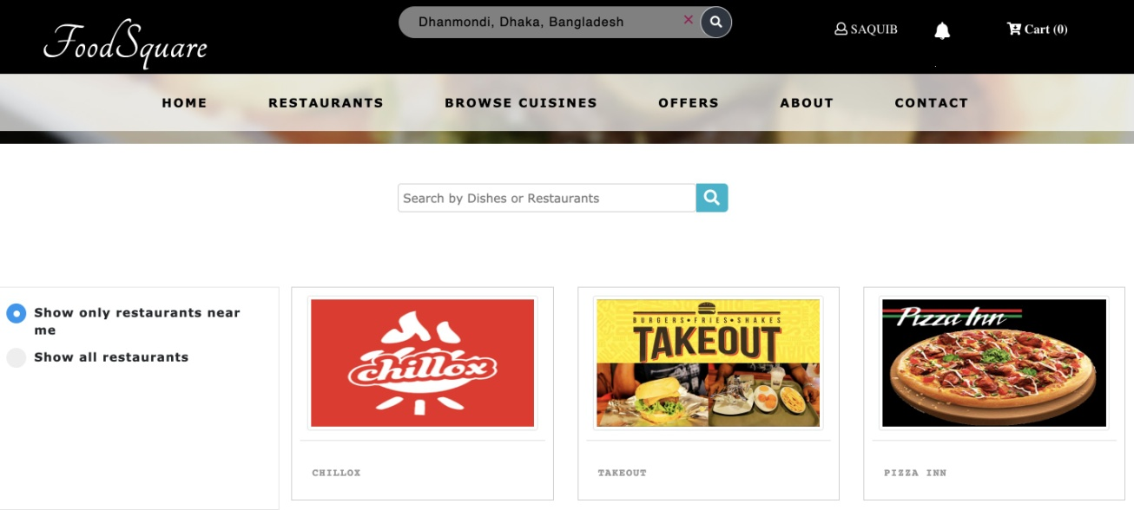

Figure 4: Nearby Restaurants

### Browse Cuisines

Also, in the *Browse Cuisines* page, a user can browse items based on many filters and search options. For example, a user can filter the items based on ratings on the items, price range etc.

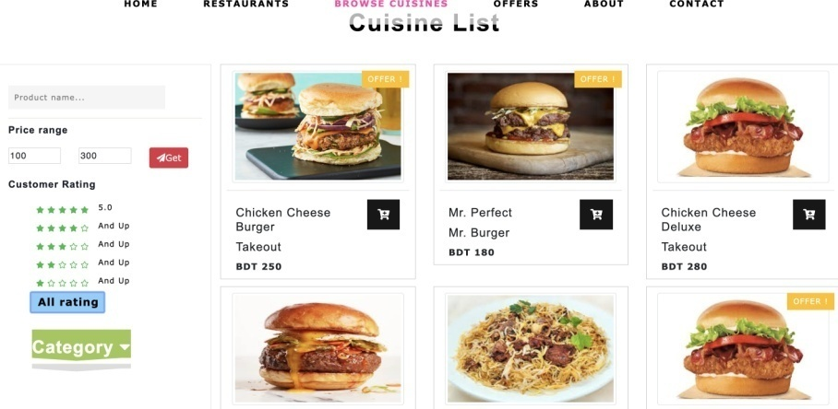

Figure 5: Filter Results

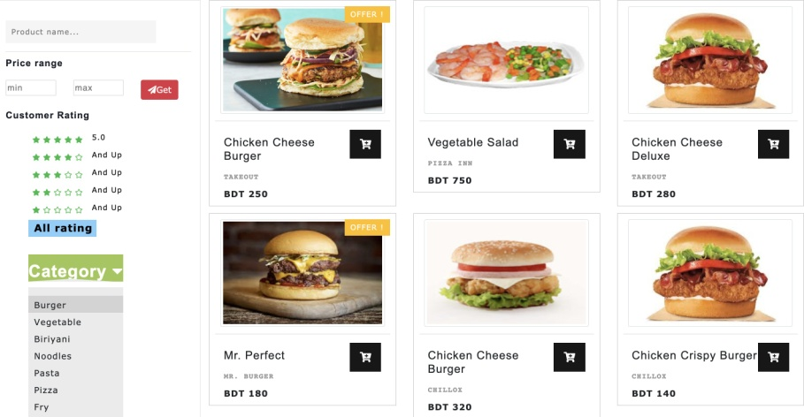

Figure 6: Search results

### Branch Unavailability

Depending on the location, restaurant branch availability will be determined and some of the restau- rants may not be able to deliver to the intended location of the customer.

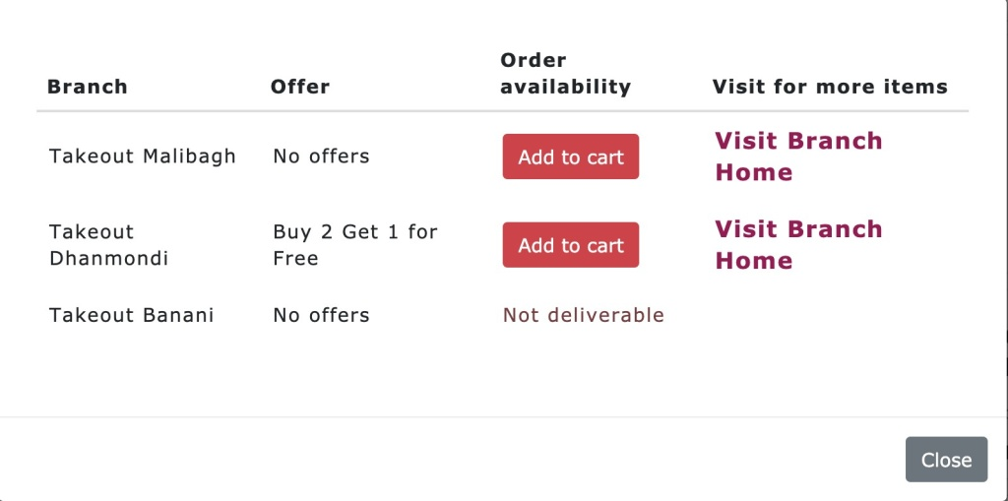

Figure 7: Branch Unavailability

### Adding food to cart and Checkout

After browsing, customers can order from a nearby restaurant, checkout the *cart*, and then the cus- tomer will be taken to the checkout page where delivery details will be asked.

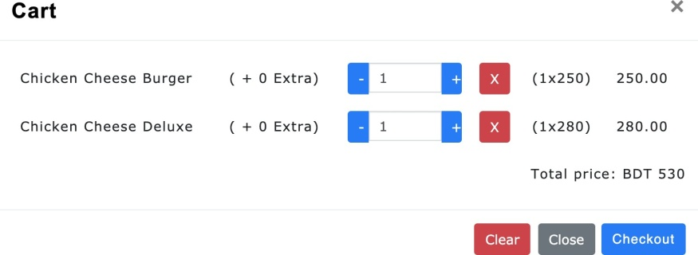

Figure 8: Cart

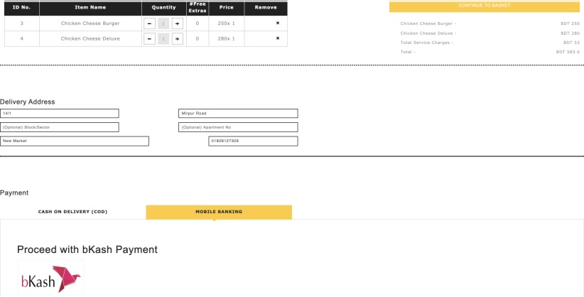

Figure 9: Delivery Details

### Payment method

Customers can use either of cash on delivery or bkash payment method. Here, bkash payment is shown.

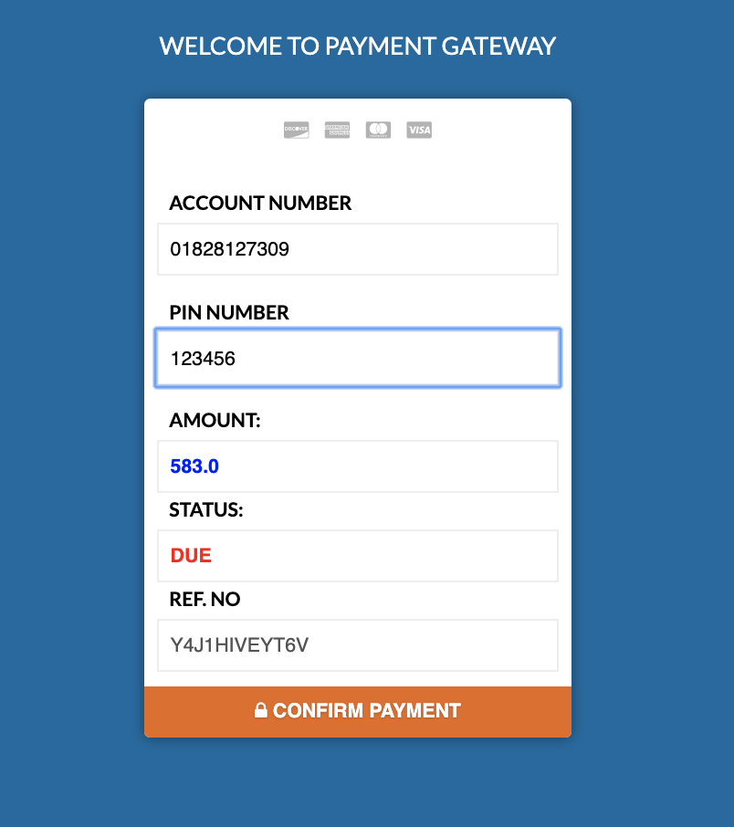

Figure 10: bKash Payment Info



Figure 11: bKash Payment Complete

### Order Placing notification

At this point order has been placed. Now it will be approved by the restaurant manager. Usually the manager approves the order within a short time. By this time a notification will appear stating that the order has been placed and sent to the restaurant authority.

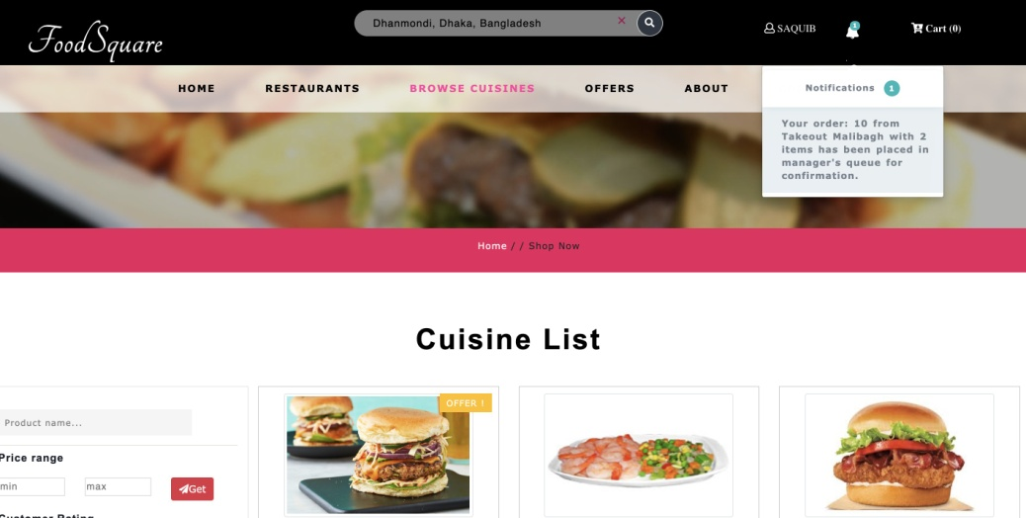

Figure 12: Order Placing Notification

### Rate the Deliveryman

By this time the customer can browse through the website and wait. As the order information keeps getting propagated, customer will be getting notifications for his order. Once the deliveryman arrives with the order, customer will be able to rate the deliveryman for the service in the homepage.

### Rate and Comment Items

Also, a customer can rate a particular item of a restaurant by clicking on View Item in that item while browsing. S/he can also provide feedback as a comment.

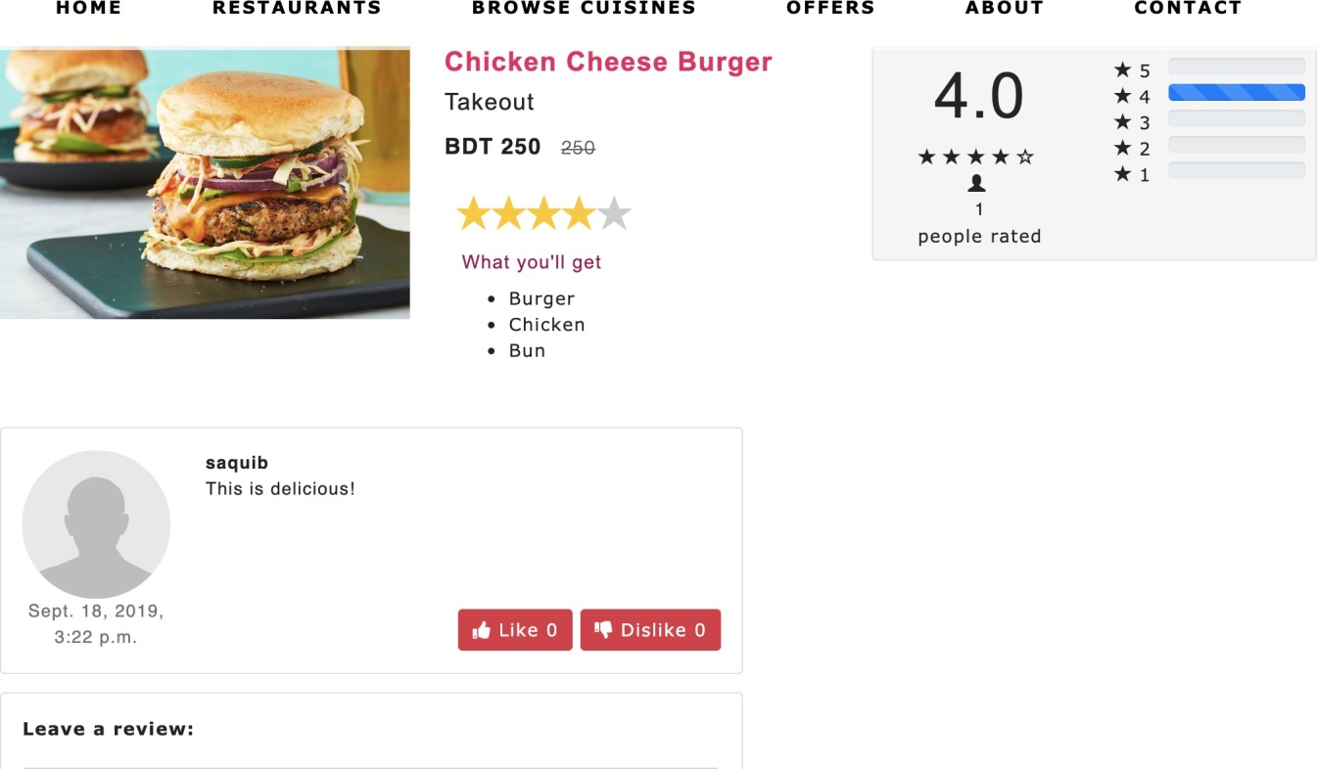

Figure 13: Rate and Comment an item

## Restaurant Manager User Guide

### Manager Register

A restaurant manager will need to open up an account as a restaurant manager in the website. The registration form will look like this.

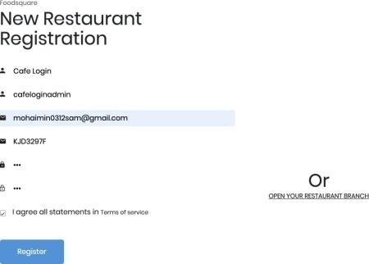

Figure 14: Manager Register 1

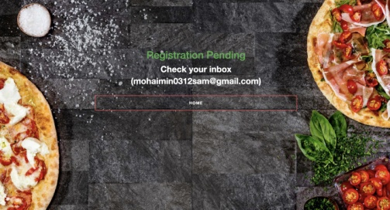

Figure 15: Manager Register 2

When the *admin* approves the request, email is sent stating the activation of the account.

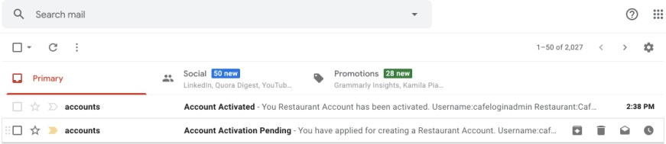

Figure 16: Email for Account Activation

### Restaurant Manager Homepage

In restaurant manager homepage, there will be a key to identify the restaurant. This key will be used for opening up the restaurant branches.

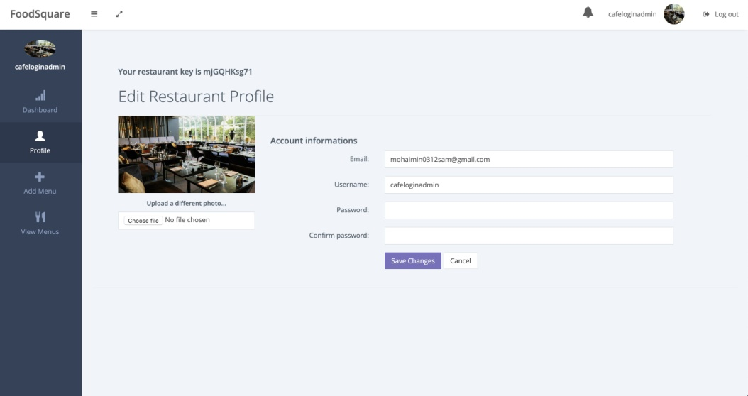

Figure 17: Restaurant Manager Homepage

### Restaurant Branch Creation

Opening up a restaurant branch is just the same as opening up a new restaurant. In the restaurant register page, there is also an option to create restaurant branch. Providing all the relevant fields along with the *restaurant key* from the restaurant manager homepage (mentioned above), a new branch of the restaurant can be created.

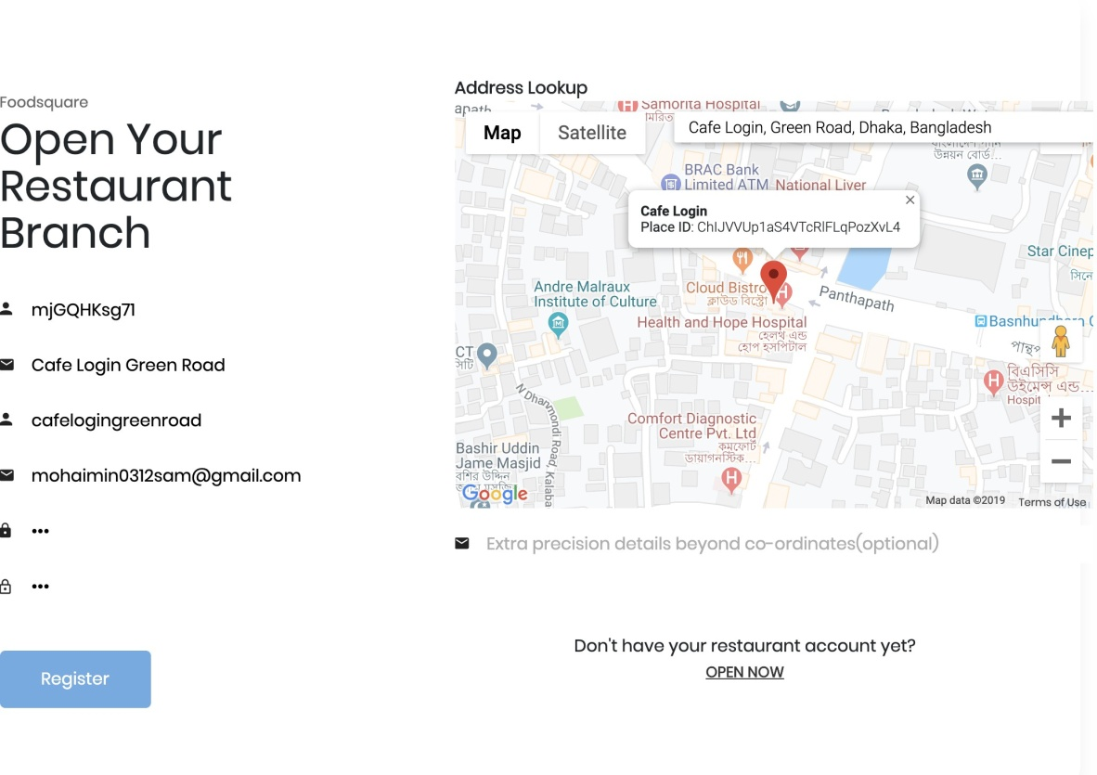

Figure 18: Restaurant Branch Manager Register

### Add Items

A restaurant manager can add item in his restaurant. In the *Add Item* tab, manager will be able to introduce a new item in the restaurant.

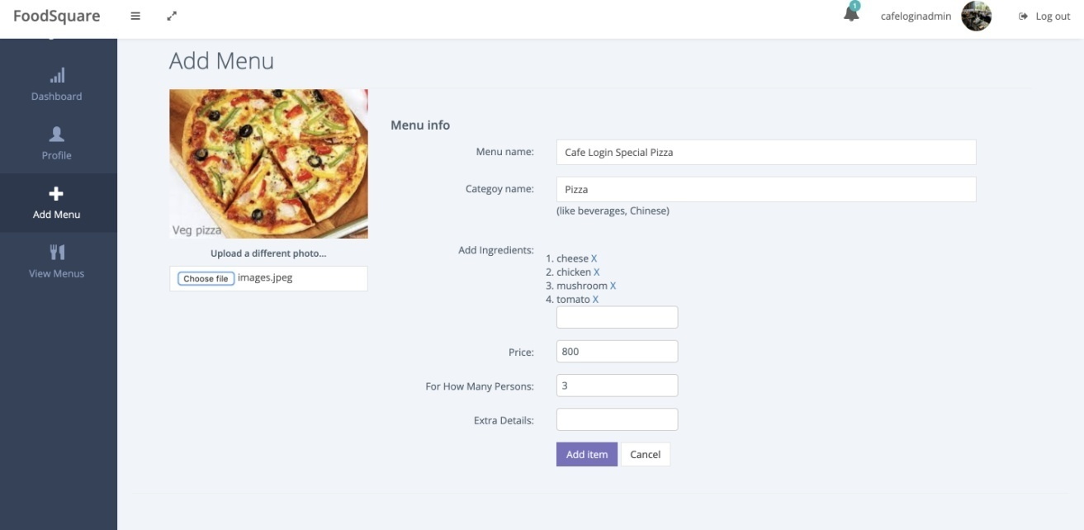

Figure 19: Add Item

### Manager Dashboard

Also, a manager can see the restaurant statistics in the *Dashboard* page. The Dashboard page contains many of the common statistics which will help him understand the restaurant sale progress. Outlet revenue, sales trend in different branches etc. are shown in this page.

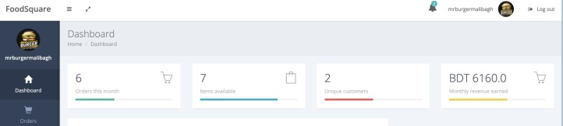

Figure 20: Manager Dashboard 1

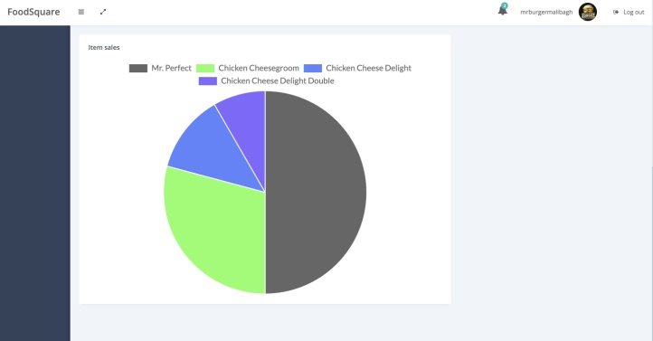

Figure 21: Manager Dashboard 2

## Restaurant Branch Manager

A restaurant branch manager will be in charge of a branch of a restaurant. So, his role in this website in also different from a *Restaurant Manager*. When the restaurant manager sets up the profile for the branch manager, s/he can manage this branch independently.

### Item Availability in the branch

Branch Manager can declare which items are currently available in the homepage.

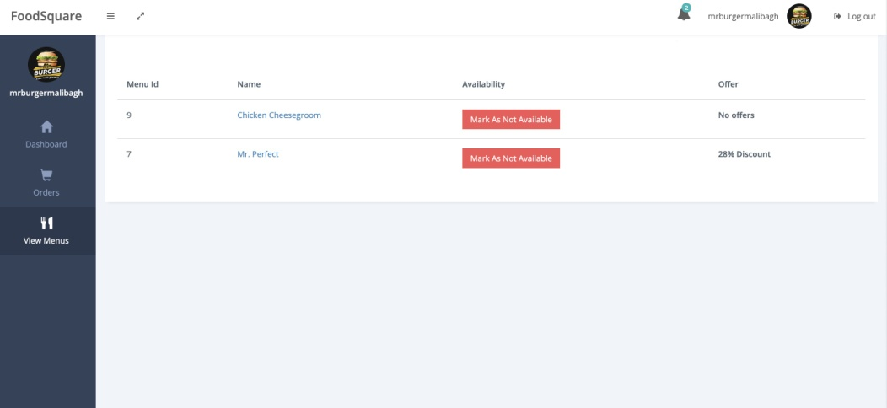

Figure 22: Branch Manager View Menus

### Add offer

Branch Manager can add offers on an item by clicking on that item.

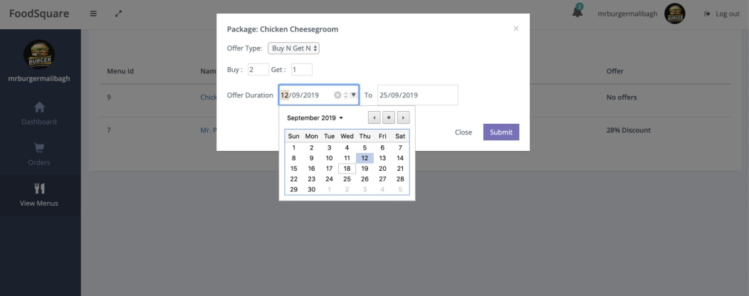

Figure 23: Add Offer

### Manage and Accept Orders

This is the most important task of a branch manager. Whenever a customer orders something, the order request comes to the branch manager who has to accept it and forward it to the deliveryman.

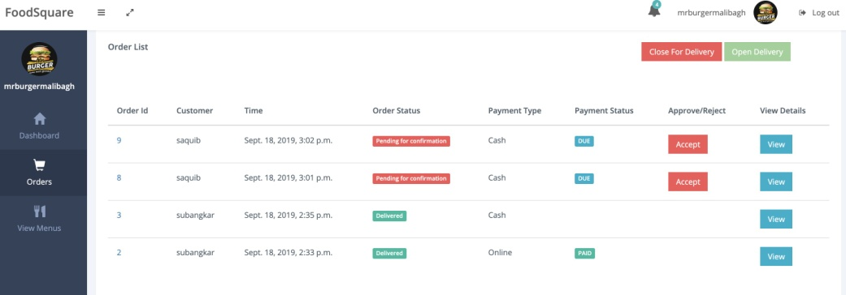

Figure 24: Accept Order

## Deliveryman User Guide

In our system, anyone can become a deliveryman if s/he is willing to be. Anyone can open up a profile in the website as a deliveryman, but it will need approval from the *admin*.

### Deliveryman Register

While opening an account, deliveryman has to assign himself/herself for one of the *zones*. S/he will be getting deliveries for that *zone* only.

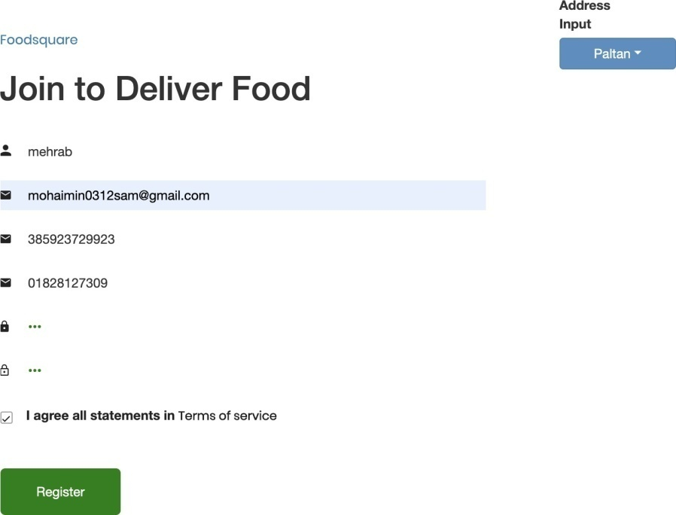

Figure 25: Deliveryman Register

### Deliveryman Homepage

Once logged in, a deliveryman’s homepage will have currently pending requests of orders in his/her

*zone*. To take an order for delivery, the *Take Delivery* button is to be pressed.

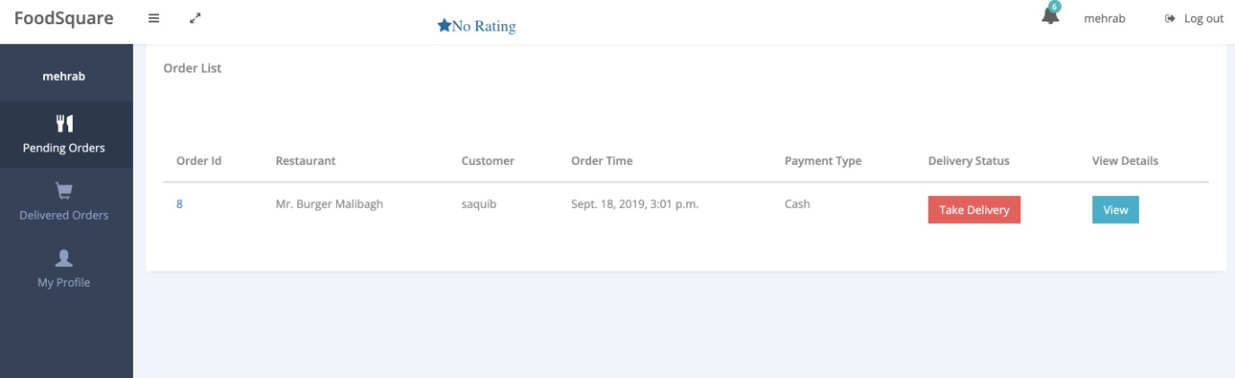

Figure 26: Deliveryman Homepage

### Complete the Delivery Process

Then, that order entry will be updated and will be waiting for the deliveryman to pick up and deliver. Once delivered to the customer, the deliveryman needs to press the *Mark As Delivered* button. This will also prompt the deliveryman to rate the customer for his/her behaviour.

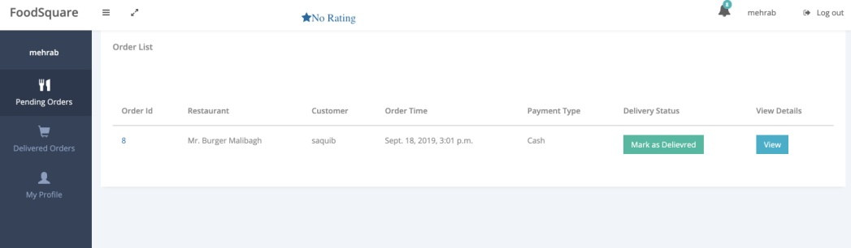

Figure 27: Delivery Completion

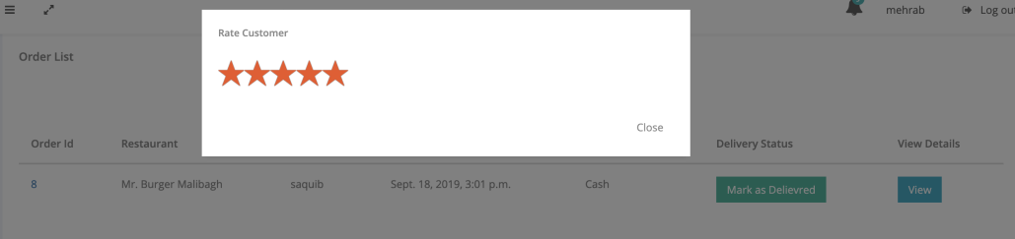

Figure 28: Rate the Customer